# Experiment No.: 01 Current to Pressure Converter

|  |  |
| --- | --- |
| **Academic Year** | **: 2021-22 Sem : I** |
| **Class** | **: TY BTech Instrumentation & Control** |
| **Course Name** | **: Process Instrumentation** |
| **Course Code** | **: IC3231** |
| **Name** | **: Shaunak Deshpande** |
| **Division** | **: IC-C** |
| **Roll No.** | **: 39** |
| **G.R. No.** | **: 11911180** |

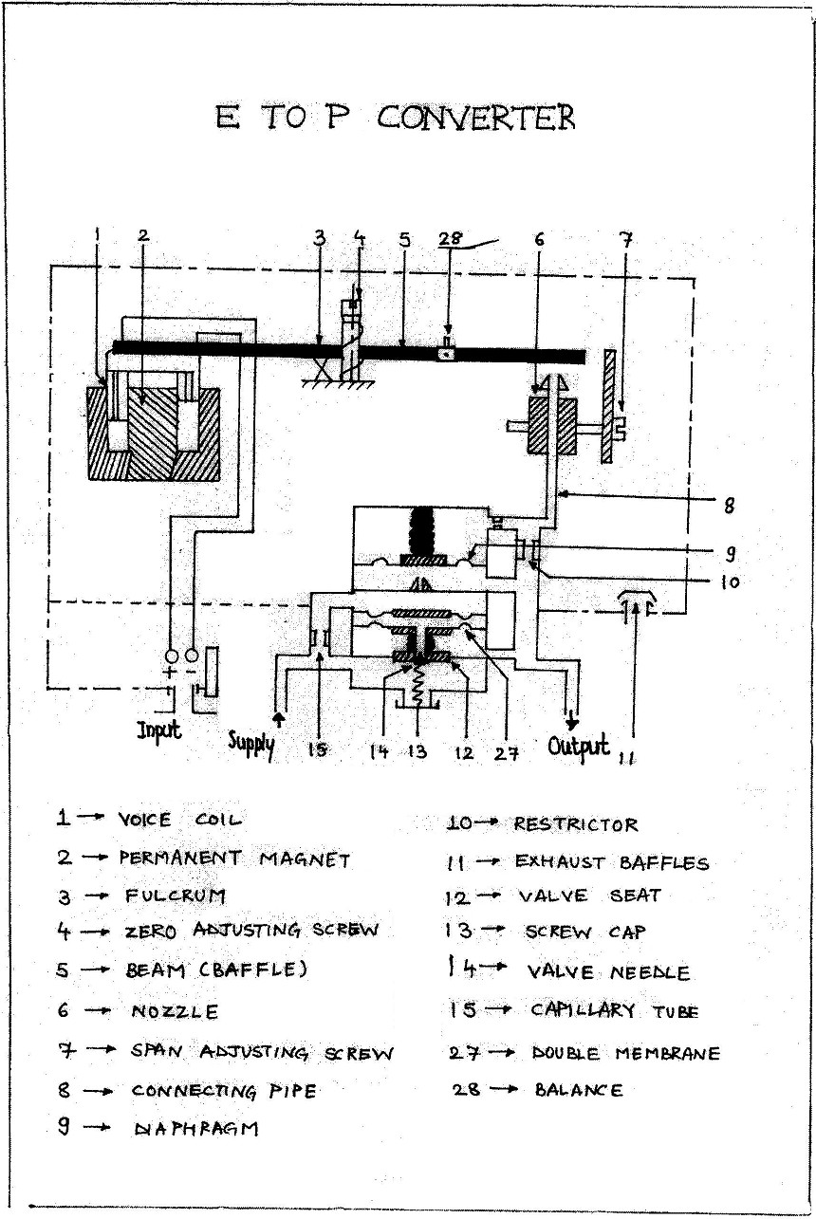

**Experiment No.: 01**

**Current to Pressure converter**

**Aim :** To study and plot the calibration curve of Current to Pressure converter.

**Apparatus :** Current to Pressure converter, Compressor, Current source, Digital multimeter, Pressure gauge, piping, connecting wires etc.

**Theory :** Current to Pressure converter is a device that converts standard current input signal (4- 20 mA) into standard pneumatic output (3-15 psi). The relation between input current and output pressures is linear.

An integral bracket is used for surface mounting of the converter. Pneumatic connection are ¼” NTP internal threaded. Electrical connections, gland span and zero adjustments are made by means of screw adjusters.

**Operation :** Refer the Figure (1),

The pick up system consist of (1) situated in the air gap of permanent magnet (2). The converter consists of nozzle (6) restrictor (10) and the baffle plate on beam (5), which is mounted on beam pivot (3). The converter serves to convert the force on the coil (produced by 4-20 mA current signal) into movement of baffle plate, which closes nozzle (6) and so increases the pressure in connecting pipe (8). The pneumatic relay consists of diaphragm (9). Valve seat and needle (12),

(14) and capillary tube (15). The increased pressure in connecting tube (8) causes diaphragm to move down closing the part below it. This result in pressure built up on the top surface of double membrane, which is connected to a valve needle (14). The valve is opened till the pressure equilibrium on the both sides of double membrane is restored. When the valve opens to restore equilibrium, the supply air flows directly to the outlet with a pressure proportional to valve opening.

### Specifications of Current to Pressure converter :

Input Signal 4-20 mA dc

Input resistance 90  ± 5

Pressure 3-15 psi / 0.2 - 1 kg/cm2

Characteristics Linear with input current

Linearity 0.5 %

Sensitivity 0.1 %

Air supply 20 psi / 1.4 kg / cm2 ± 10 %

Power supply 240 V AC ± 10 % 50 Hz

Consumption 30 L/H typically

### Procedure:

1. Switch on the compressor and let the pressure build up to 20 psi.
2. Vary the current in terms of percentage on the calibrated scale such as 0, 25, 50, 75 etc. notes down the corresponding pressure reading. Take five readings up to 100 on the calibrated scale.
3. Now gradually decrease the current from 100 % to 0% and again note down the pressure reading.
4. Plot the graph Pressure Vs Current for increasing as well as decreasing readings.
5. Calculate the % error and sensitivity.

### Observations:

|  |  |  |  |  |  |
| --- | --- | --- | --- | --- | --- |
| **Sr.**  **No.** | **Input Current mA** | **Expected Pressure Psi** | **Actual Pressure (Increasing) psi** | **Actual Pressure (Decreasing) psi** | **% Accuracy in terms of span** |
| 1. | 4 | 3 | 0.402 | 0.402 | -4.04 |
| 2. | 8 | 6 | 0.601 | 0.601 | -4.02 |
| 3. | 12 | 9 | 0.81 | 0.81 | -4.2 |
| 4. | 16 | 12 | 0.616 | 0.616 | 3.68 |
| 5. | 20 | 15 | 0.824 | 0.824 | 3.52 |

**Sample Calculation:**

% Error = [(Required Pressure – Actual pressure) / Span ]*100

### Conclusion:

In this lab session, we have successfully understood the working of current to pressure

convertor. We have also implemented this practical to convert the input signal of (1-20mA) to

output pressure of (0.2-1 kg/cm2). Also we learned about calibrating the instrument for getting accurate readings, and implemented the same and after the experiment, we are able to detect any faults which maybe present in the instrument.

**Working Principle:**

The input to the I/P converter is control signal from electronic controllers varying in the range of 4 mA to 20 mA. This input is connected to the voice coil assembly which consists of a permanent magnet and an electromagnetic coil. The name voice call is because of its resemblance with the audio amplifier circuit. A soft iron piece is attached to the flapper which is attracted towards coil due to magnetisation of the coil. The extent of pull towards coil depends on the magnitude of the current passing through the coil which is a control signal or output of the controller.

**PreTest:**

**­­**

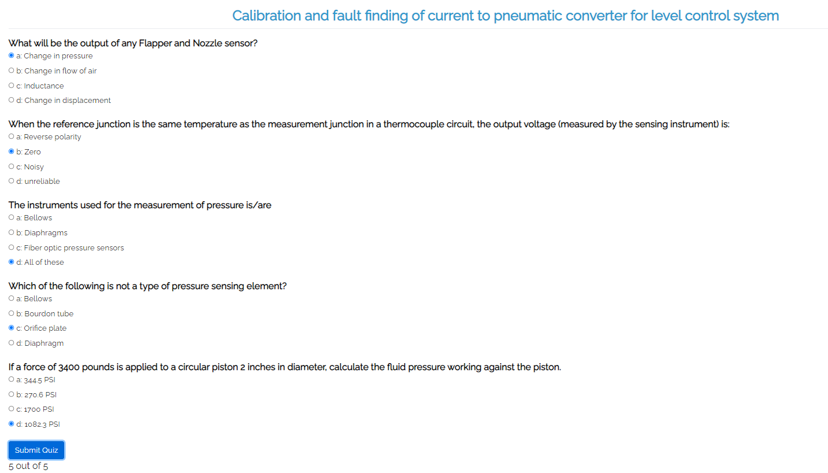

**Screenshots of the Tasks completed on the Virtual Lab:**

(Introduction, Configuration, Connections, Characterization, Calculations, Calibration, Final observation Table, Fault Finding, etc.)

1. Introduction

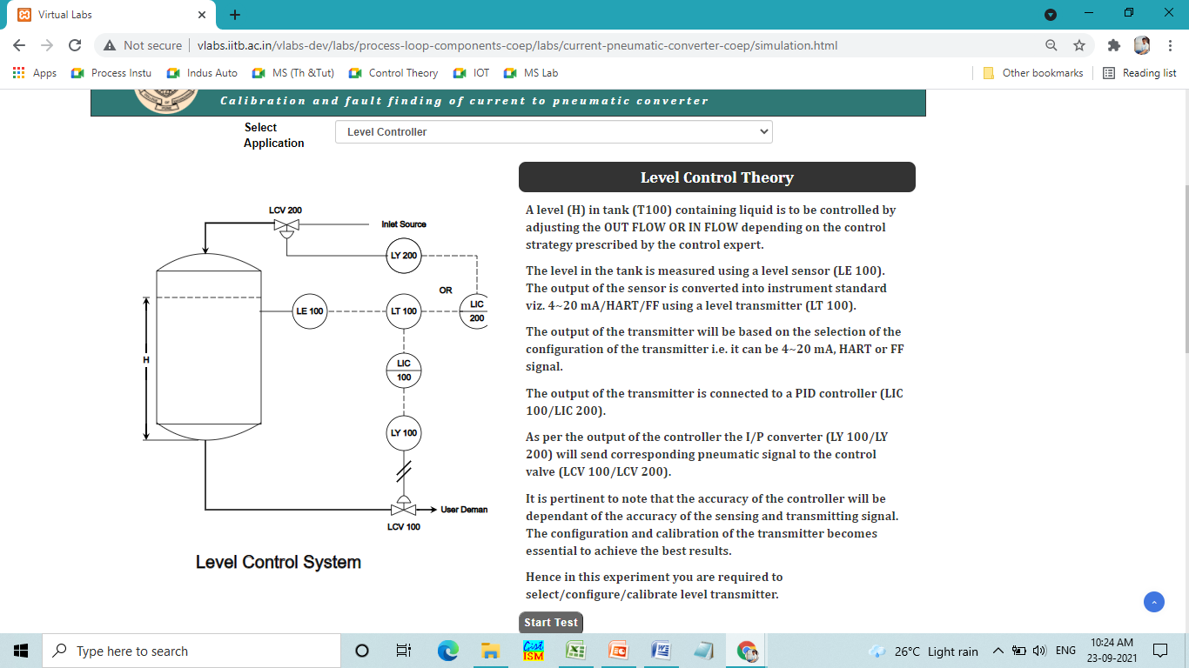

1. Configuration

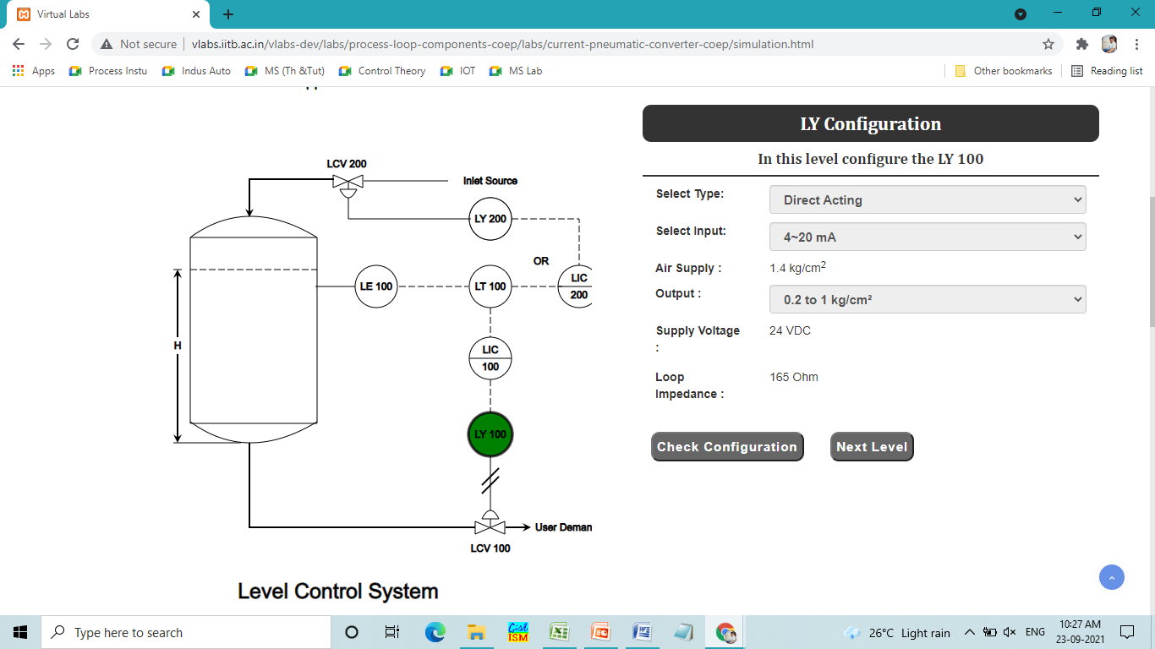

1. Connections

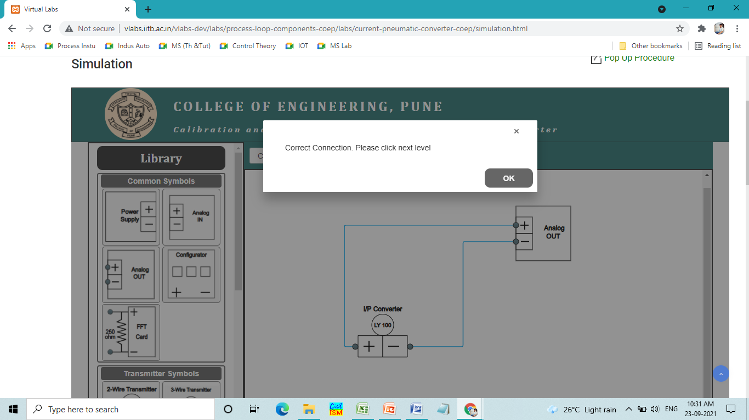

1. Observations

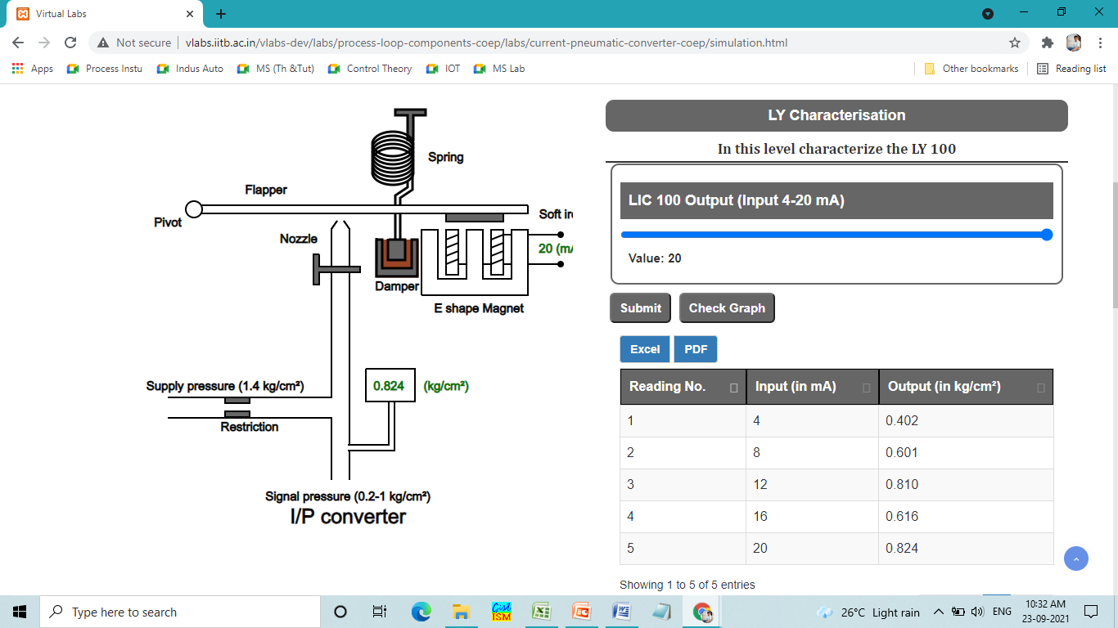

1. Calibration

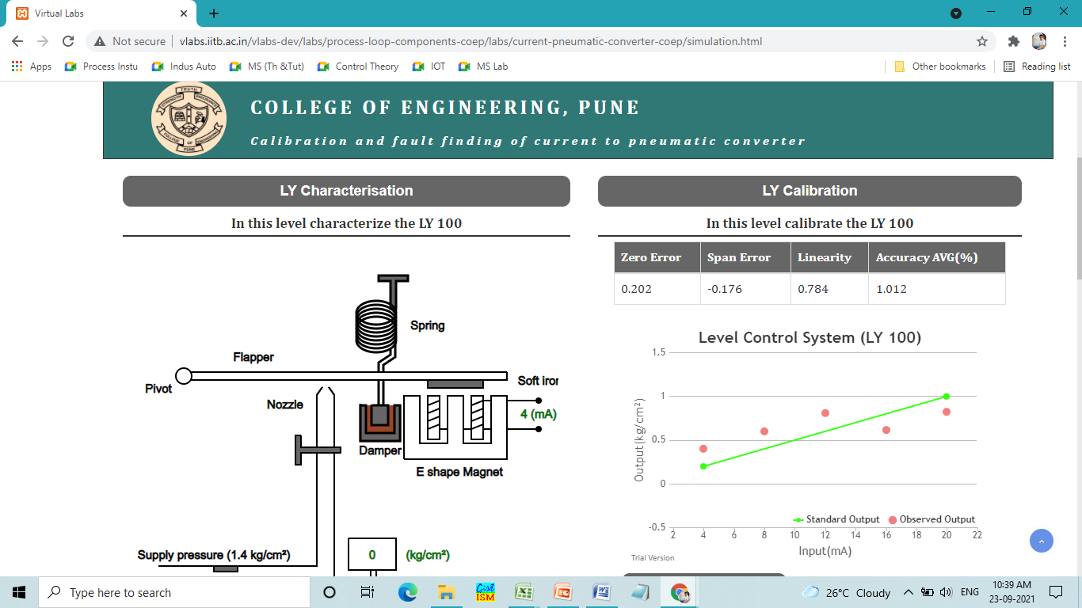

1. Final Observations

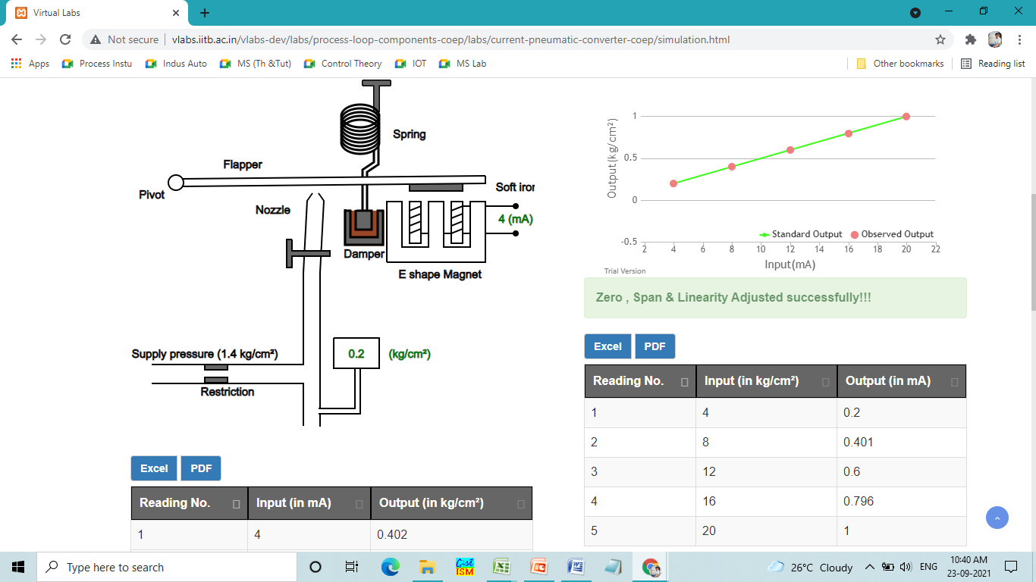

1. Fault Finding

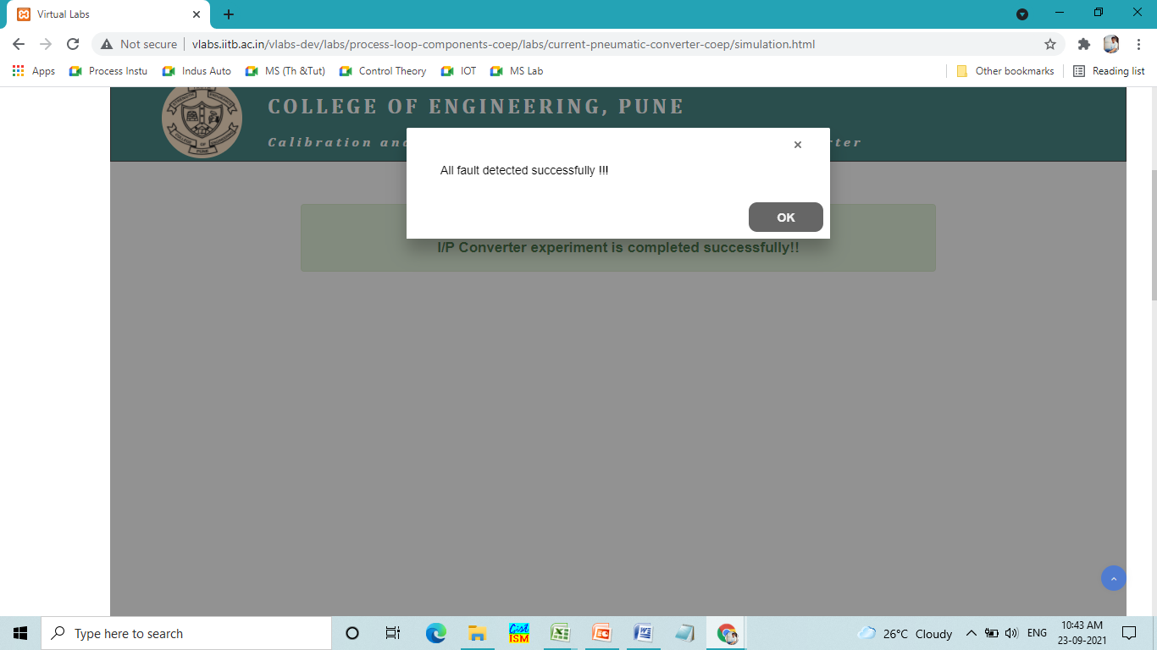

**PostTest:**

